PDPA Malaysia Compliance for Log360
Strengthen data protection and meet PDPA Malaysia compliance with Log360.
Region: Malaysia | Type: Data Privacy | Category: Compliance | Pricing: Free

Overview
The PDPA Malaysia compliance extension in Log360 helps organizations meet Malaysia's Personal Data Protection Act 2010 (Act 709), the primary legislation governing commercial processing of personal data in Malaysia applying to all data users in commercial transactions involving personal data of Malaysian residents by providing centralized log management, access control auditing, data integrity monitoring, and real-time security event detection. The platform supports PDPA Malaysia requirements for consent and lawful processing oversight, notice and transparency controls, security safeguards, data retention governance, data integrity assurance, data subject access and correction rights, and cross-border data transfer compliance.
For Consent and Lawful Data Processing Oversight, Log360 tracks user activity, authentication events, and policy changes to monitor compliance with consent-based access controls and detect unauthorized personal data processing. To address Notice, Transparency and Disclosure Controls, the platform monitors policy changes, GPO updates, and directory configurations to verify that data processing governance controls align with disclosed purposes and restrict unauthorized disclosure. The extension also supports Security Measures to Protect Personal Data by providing capabilities that monitors failed logon attempts, risky sign-ins, Windows threat detection, file integrity events, and firewall activity to identify and prevent unauthorized access to personal data.

Key Features
- Data Retention and Storage Governance: Log360 monitors database DDL changes, data modification events.
- Data Integrity and Accuracy Assurance: Log360 monitors database DML changes, Oracle and SQL Server modification events.
- Data Subject Access and Correction Rights: Log360 monitors user account management events, Entra ID user changes.
- Cross-Border Data Transfer Compliance: Log360 monitors AWS infrastructure activity, cloud IAM permissions, Salesforce data access.

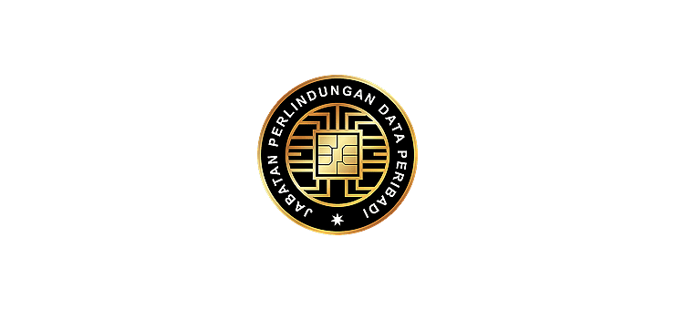
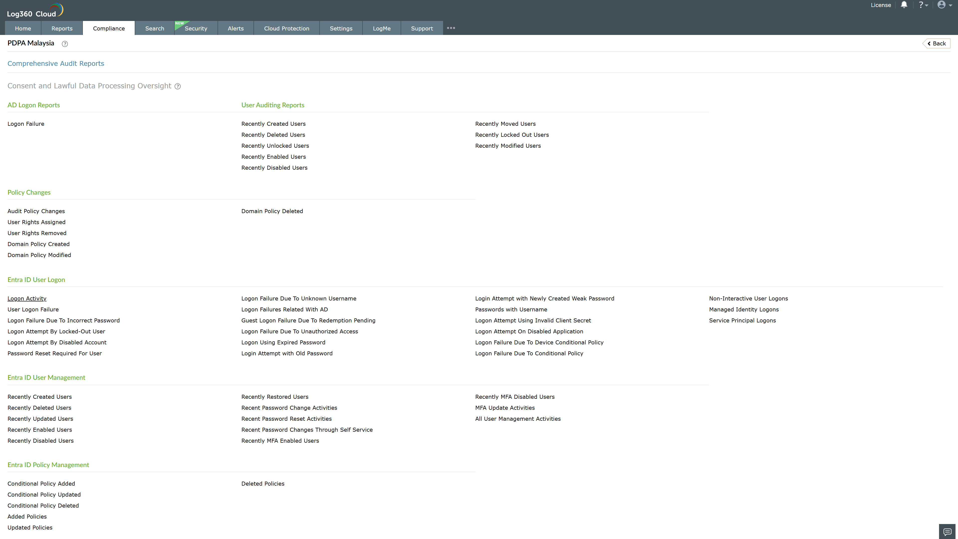
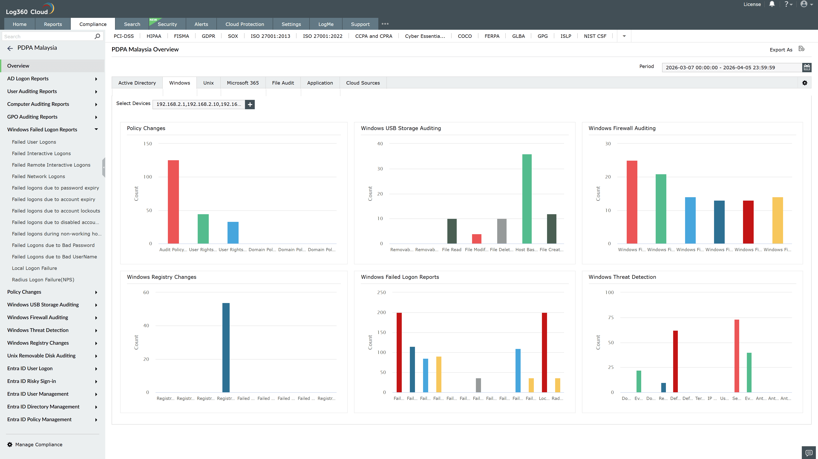
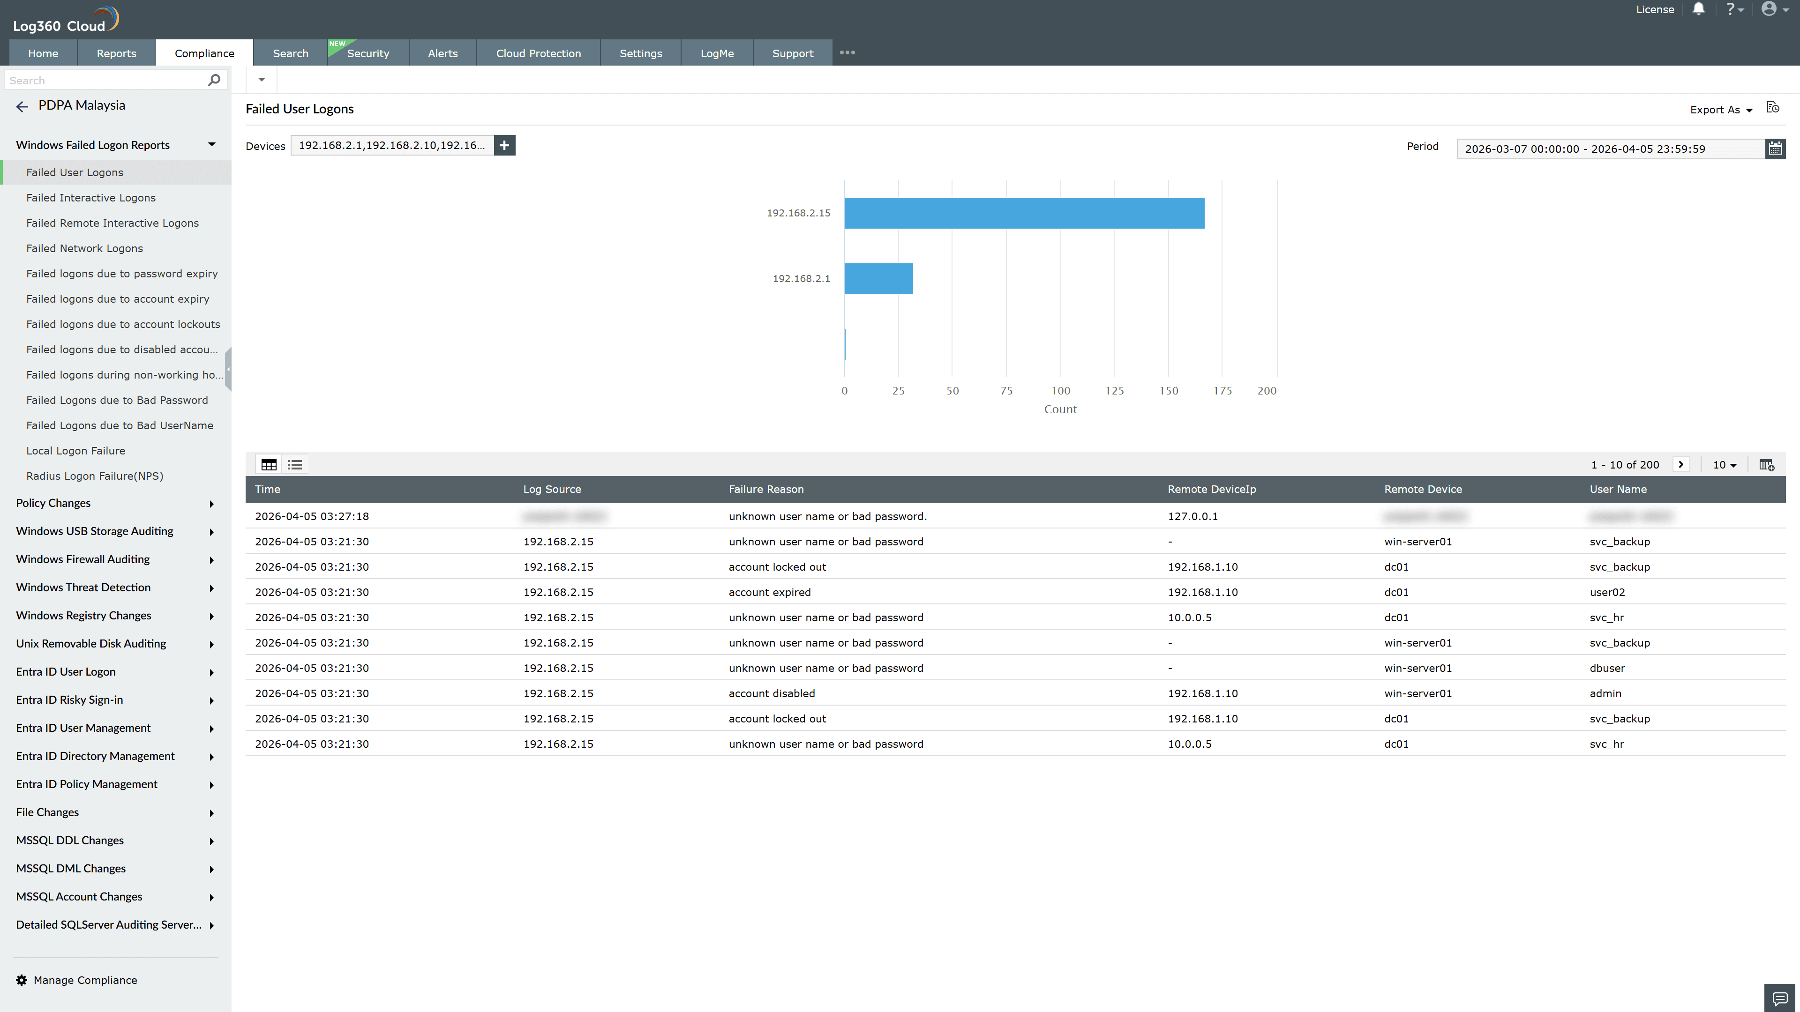
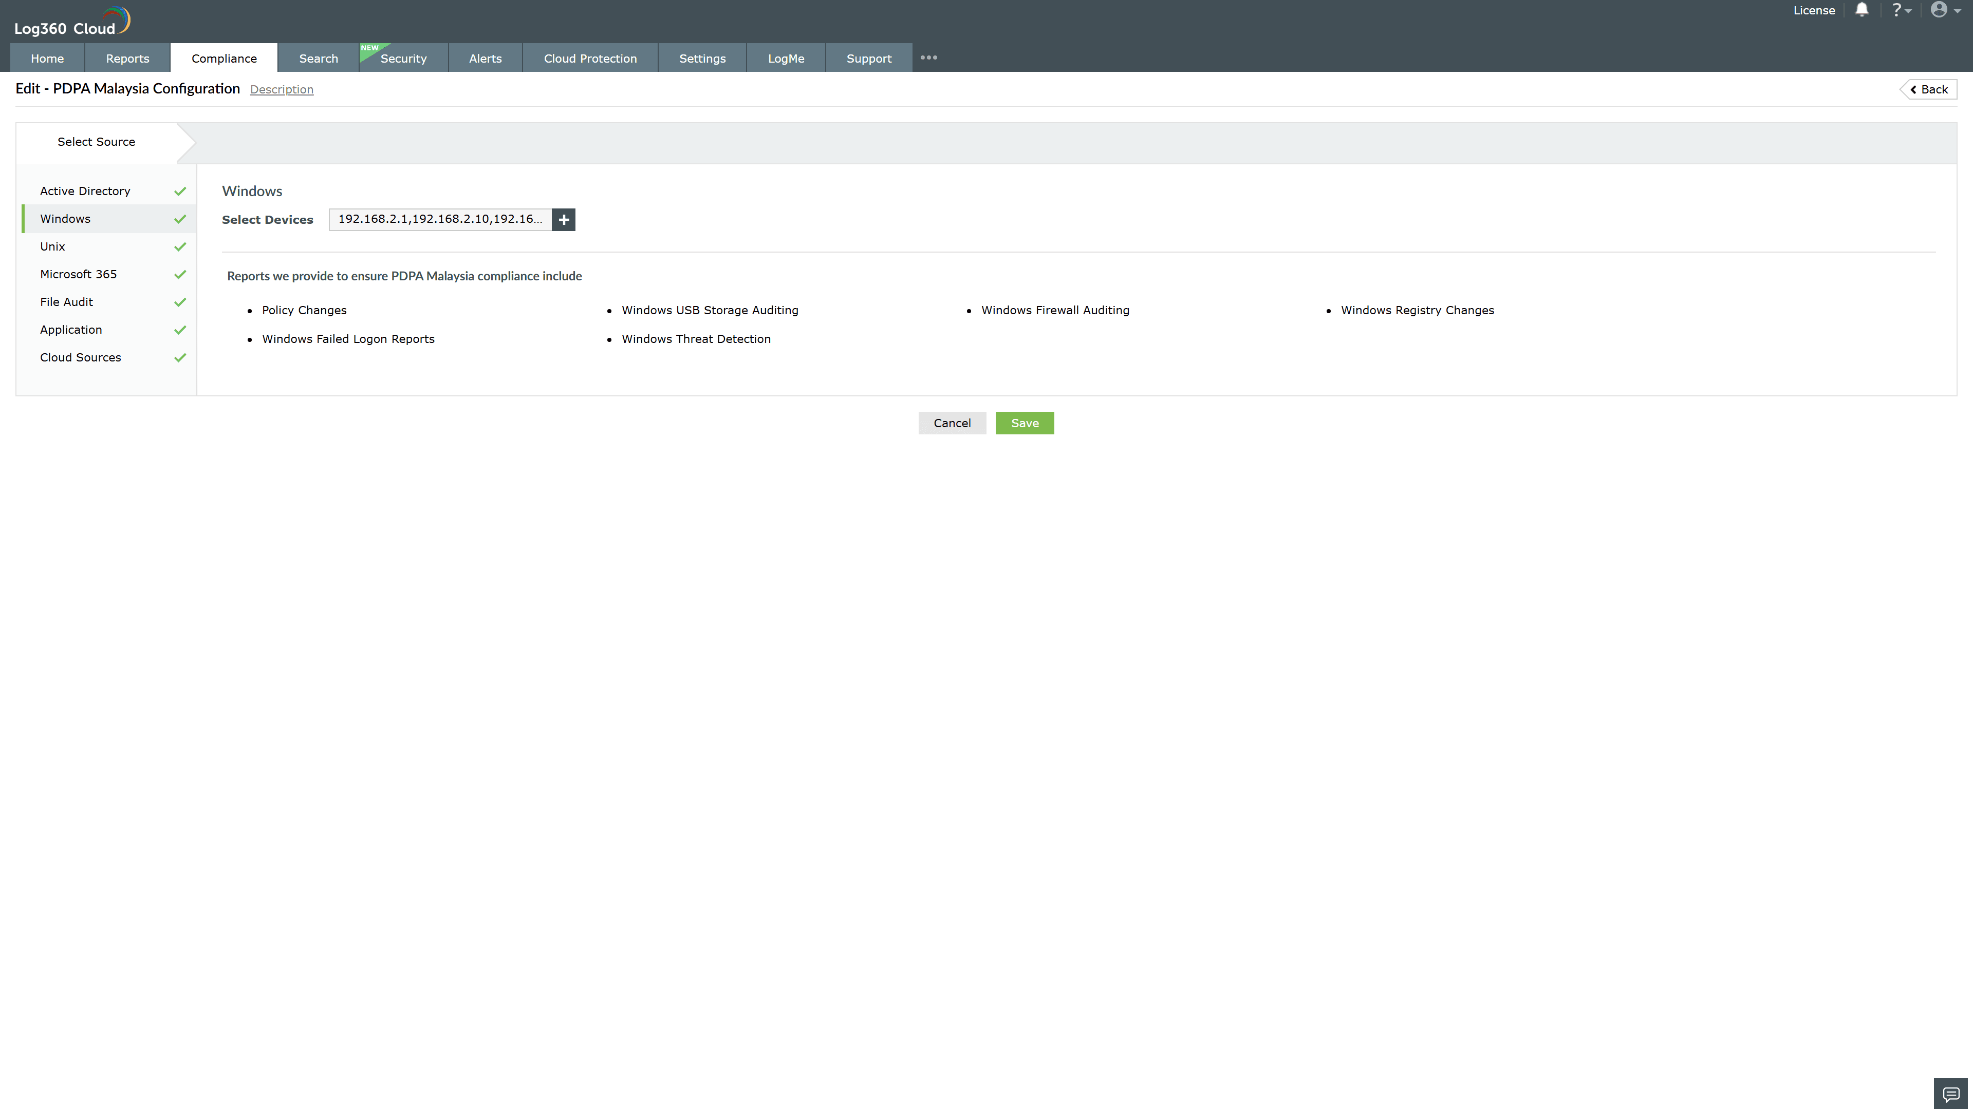
Valid Submission : Yes
Supported Editions : Free, Basic, Standard, Professional, MSSP
Help Document : https://www.manageengine.com/log-management/help/integrations/compliance-extensions.html
Help Video : Not provided
Tags : Log360, Compliance, Privacy monitoring, Data privacy, Regulatory compliance
Supported DCs : US, IN, JP, CA, AU, UK and EU
Privacy Policy:
Terms of Service:
Release Notes:
Predefined reports for the PDPA Malaysia.

